FULL STACK WEB DEVELOPMENT
LABORATORY RECORD — EXPERIMENT 01

1. BASIC INFORMATION
Experiment No. | 01
Date | 27/07/2026
Title | Design Static Webpage using HTML Components
Application | College Information Portal
Course Outcome | CO1

2. AIM
To design and develop a static College Information Portal using basic HTML components such as headings, paragraphs, hyperlinks, lists, tables, images, forms, audio, video, and footer elements.

3. OBJECTIVE
- Create a basic static webpage using HTML.
- Organize college information using headings and paragraphs.
- Display departments and facilities using ordered and unordered lists.
- Display student information using an HTML table.
- Create a student registration form using different input controls.
- Embed images, audio, and video in the webpage.

4. THEORY
HTML (HyperText Markup Language) is used to structure the content of webpages. A static webpage displays predefined content and does not require server-side processing to present the information. HTML elements such as headings, paragraphs, lists, tables, links, forms, images, audio, video, and footer elements can be combined to create a structured webpage.
In this experiment, the webpage is organized as a College Information Portal. The page contains college information, department and facility lists, student details, a registration form, college images, an audio player, and a video player.

5. SYSTEM REQUIREMENTS
Hardware | Software / Technology
Processor: Core i5 or equivalent  RAM: 8 GB or above  Storage: 10 GB free space | Windows 10/11  Visual Studio Code  Google Chrome / Microsoft Edge  HTML5

6. PAGE DESIGN / STRUCTURE
The webpage is arranged in a simple top-to-bottom structure. It starts with the portal heading and college link, followed by college information, departments, facilities, student details, college images, registration form, college anthem, college video, and footer.
College Portal → About College → Departments → Facilities → Student Details → Registration → Multimedia → Footer

7. ALGORITHM / PROCEDURE
- Create an HTML file with the basic html, head, and body structure.
- Add a title for the College Information Portal.
- Add a heading and hyperlink for the college website.
- Display college information using headings and paragraphs.
- Create an ordered list for departments.
- Create an unordered list for facilities.
- Create a table to display student details.
- Insert college logo and campus images using the img element.
- Create a student registration form using text, email, password, radio, checkbox, select, date, number, color, range, and textarea controls.
- Add audio and video elements for multimedia content.
- Add a footer containing the copyright information.
- Open the webpage in a browser and verify the complete output.

8. SOURCE CODE
<!DOCTYPE html>
<html>
<head>
<title>College Information Portal</title>
</head>
<body>
<h2>College Information Portal</h2>
<a href="https://www.anits.edu.in/">College Website</a>
<h3>About College</h3>
<p>Anil Neerukonda Institute of Technology and Sciences is one of the
leading engineering colleges in Andhra Pradesh.</p>
<h3>Departments</h3>
<ol>
<li>CSE</li>
<li>ECE</li>
<li>EEE</li>
<li>Mechanical</li>
</ol>
<h3>Facilities</h3>
<ul>
<li>Library</li>
<li>Hostel</li>
<li>Sports</li>
<li>Transport</li>
</ul>
<h3>Student Details</h3>
<table border="1">
<tr>
<th>Roll No</th><th>Name</th><th>Branch</th><th>Email</th>
</tr>
<tr>
<td>101</td><td>Sai Shishir</td><td>CSM</td><td>saishishir@gmail.com</td>
</tr>
<tr>
<td>102</td><td>Rahul</td><td>CSE</td><td>rahul@gmail.com</td>
</tr>
</table>
<h3>College Logo</h3>
<img src="college-logo.jpg" alt="College Logo">
<h3>Student Registration Form</h3>
<form>
Name: <input type="text"><br>
Email: <input type="email"><br>
Password: <input type="password"><br>
Gender:
<input type="radio" name="gender"> Male
<input type="radio" name="gender"> Female<br>
Hobbies:
<input type="checkbox"> Sports
<input type="checkbox"> Music
<input type="checkbox"> Reading<br>
Branch:
<select>
<option>CSE</option>
<option>CSM</option>
<option>ECE</option>
</select><br>
Date of Birth: <input type="date"><br>
Mobile Number: <input type="number"><br>
Favorite Color: <input type="color"><br>
Satisfaction: <input type="range"><br>
Comments:<br>
<textarea></textarea><br>
<input type="submit">
<input type="reset">
</form>
<h3>College Anthem</h3>
<audio controls>
<source src="college.mp3" type="audio/mpeg">
</audio>
<h3>College Video</h3>
<video controls width="320">
<source src="college.mp4" type="video/mp4">
</video>
<footer>
<p>© 2026 College Information Portal</p>
</footer>
</body>
</html>

9. CODE EXPLANATION
HTML Component | Purpose
h1 / h2 / h3 | Displays headings of different levels.
p | Displays paragraph content.
a | Creates a hyperlink.
ol / ul / li | Creates ordered and unordered lists.
table / tr / th / td | Displays student information in tabular form.
img | Displays college images.
form / input | Collects student registration information.
select / option | Provides a dropdown list.
textarea | Accepts multi-line comments.
audio / video | Embeds multimedia content.
footer | Displays the bottom section of the webpage.

10. TEST CASES AND EXECUTION DATA
Test Case | Action / Input | Expected Result | Status
TC-01 | Open index.html in browser | College portal page is displayed | Pass
TC-02 | Check departments and facilities | Lists are displayed correctly | Pass
TC-03 | Check student details | Student table is displayed correctly | Pass
TC-04 | Check registration form | All required form controls are visible | Pass
TC-05 | Check audio and video | Multimedia controls are displayed | Pass

11. EXECUTION STEPS
- Open the Experiment-01-Static-Webpage folder in Visual Studio Code.
- Open the HTML file from the src folder.
- Ensure the image and multimedia files are available at their specified paths.
- Save the HTML file.
- Open index.html in Google Chrome or Microsoft Edge.
- Verify the college information, lists, table, images, registration form, audio, video, and footer.
- Capture the final webpage output.

12. OUTPUT
The following is the actual output captured while executing the College Information Portal. It shows the college information, departments, facilities, student details, registration form, and multimedia sections.
Figure 1: College Information Portal — Actual Output
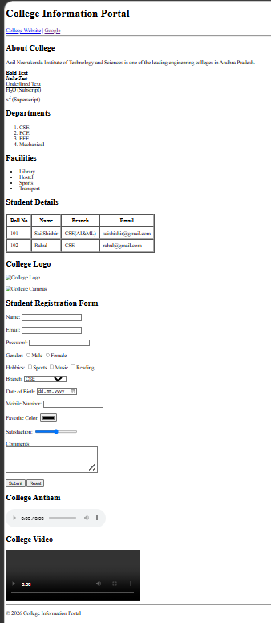

13. RESULT / CONCLUSION
The College Information Portal was successfully designed and executed as a static webpage using HTML components. The experiment demonstrated the use of headings, paragraphs, hyperlinks, lists, tables, images, forms, multimedia elements, and footer content.

14. PRECAUTIONS
- Use the correct HTML tag for each type of content.
- Close all HTML elements properly.
- Check image, audio, and video file paths before execution.
- Use meaningful alternative text for images.
- Save the file before refreshing the browser.
- Verify the form controls and table structure in the browser.

15. VIVA-VOCE QUESTIONS
1. What is HTML?
HTML is a markup language used to structure content on webpages.
2. What is a static webpage?
A static webpage displays predefined content without server-side processing.
3. What is the use of the <table> element?
It is used to display data in rows and columns.
4. Why is the <form> element used?
It is used to collect information from users.
5. Which HTML elements are used for multimedia?
The <audio> and <video> elements are used to embed multimedia.

